**THE INDIVIDUAL** **DEVELOPMENT PLAN WILL SAY…**

* What support your child needs to learn and develop
* Who is responsible for ensuring that he/she receives the support they need
* Where they will receive this support
* How we will know if the support has helped your child in the way it was intended.

**WHAT’S NEXT?**

Following the review, the Plan is shared with all partners. This will be a live electronic document that will be reviewed regularly as required and every 12 months at least. Access to the electronic document will be granted to everyone involved with the child.



PERSON CENTRED APPROACH AND INDIVIDUAL DEVELOPMENT PLAN



**Mrs Gratton ALNCo**

**01633 647488**

**Claire.gratton@wcp.schoolsedu.org.uk**

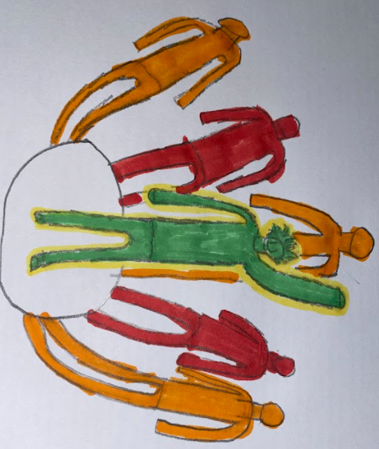

# Torfaen County Borough Council - My Council Services

**WHAT IS AN INDIVIDUAL DEVELOPMENT PLAN (IDP)?**

The Individual Development Plan (IDP) is a single plan that is put in place after determining that a pupil has ALN. The IDP includes a description of the child/young person's ALN, and the Additional Learning Provision (ALP) put in place in order to meet those needs must be noted.

**HOW IS THE IDP DRAWN?**

A Person Centred Review is undertaken in order to ensure that learners and their families are placed at the centre of planning, reviewing and making decisions about what matters in their lives, and the support, namely the additional provision, they require in order to achieve their aspirations.

## **WHO WILL BE PRESENT?**

Usually, everyone who works with the child will be invited to attend, For example -

Parents, child/young person, ALNCo, Educational Psychologist, Health, Teaching Assistant, Class Teacher, Head of Year, i.e. Any professional who is contributing to the child/young person’s support.

WHAT WILL HAPPEN AT THE MEETING

There is a laid-back environment in a Person Centred Review, with refreshments and chairs laid out informally.

A facilitator will guide everyone through the process in order to contribute information and agree on person centred outcomes and actions.

## **YOU WILL BE ASKED TO DISCUSS…**

* What you appreciate about your child
* Your aspirations for your child
* What matters to your child
* What matters for your child
* The best way to support your child
* What works and what does not work from your point of view
* Any questions you may have

## **AT THE END OF THE REVIEW**

By the end of the Review, the facilitator will ensure that everyone has agreed on Person Centred outcomes, and on actions that need to be achieved. The aim of the Action Plan is to ensure that everyone can see what needs to be done to support your child/young person to learn and fulfil their dreams.

